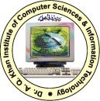

**ASSIGNMENT**

**1**

Submitted To

Mrs. Maheen Nadir

Submitted By

Haseeb Ur Rehman

(202202034)

BSCS-7

Computer Vision

Department of Computer Science

Dr. A. Q. Khan Institute of Computer Science and

Information Technology

